Laboratory Work 3
DML Operations
Student: Saken Aikhanym

Task 1. Generate and insert 200 random rows in the airport database.
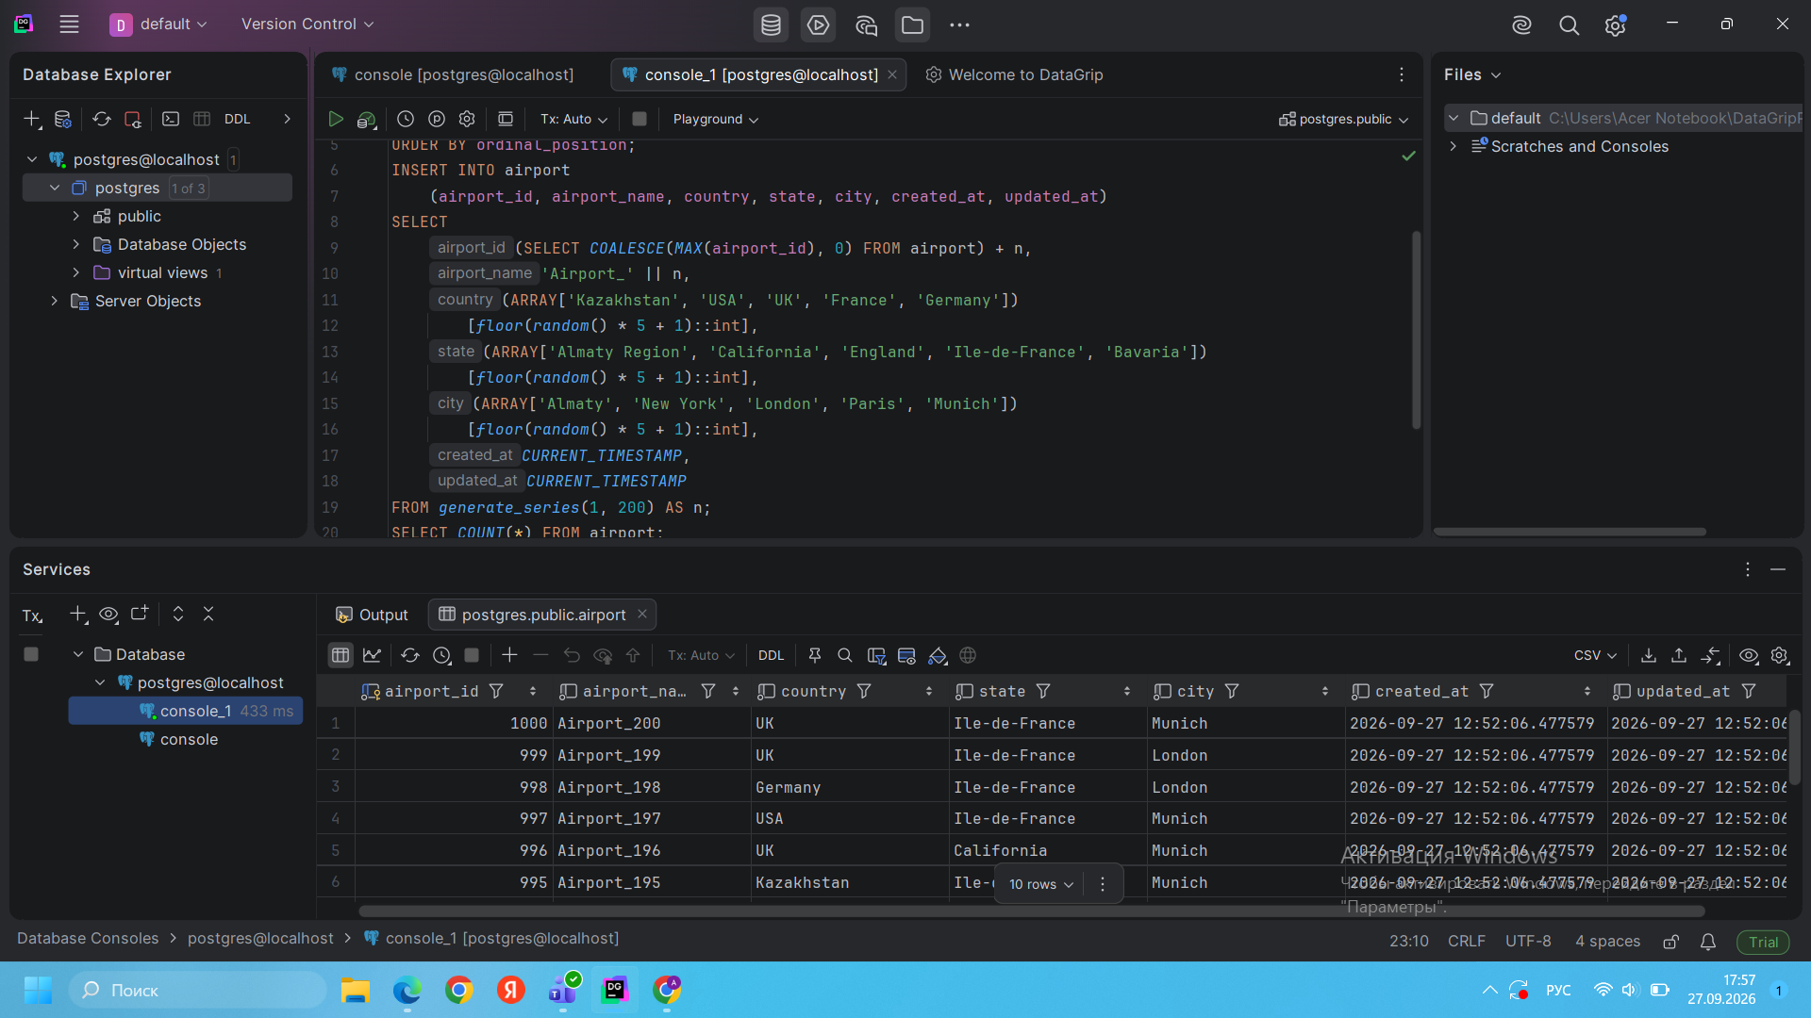
Result: 200 random airport records were successfully generated and inserted into the airport table.
Task 2. Add a new airline named “KazAir” based in Kazakhstan.
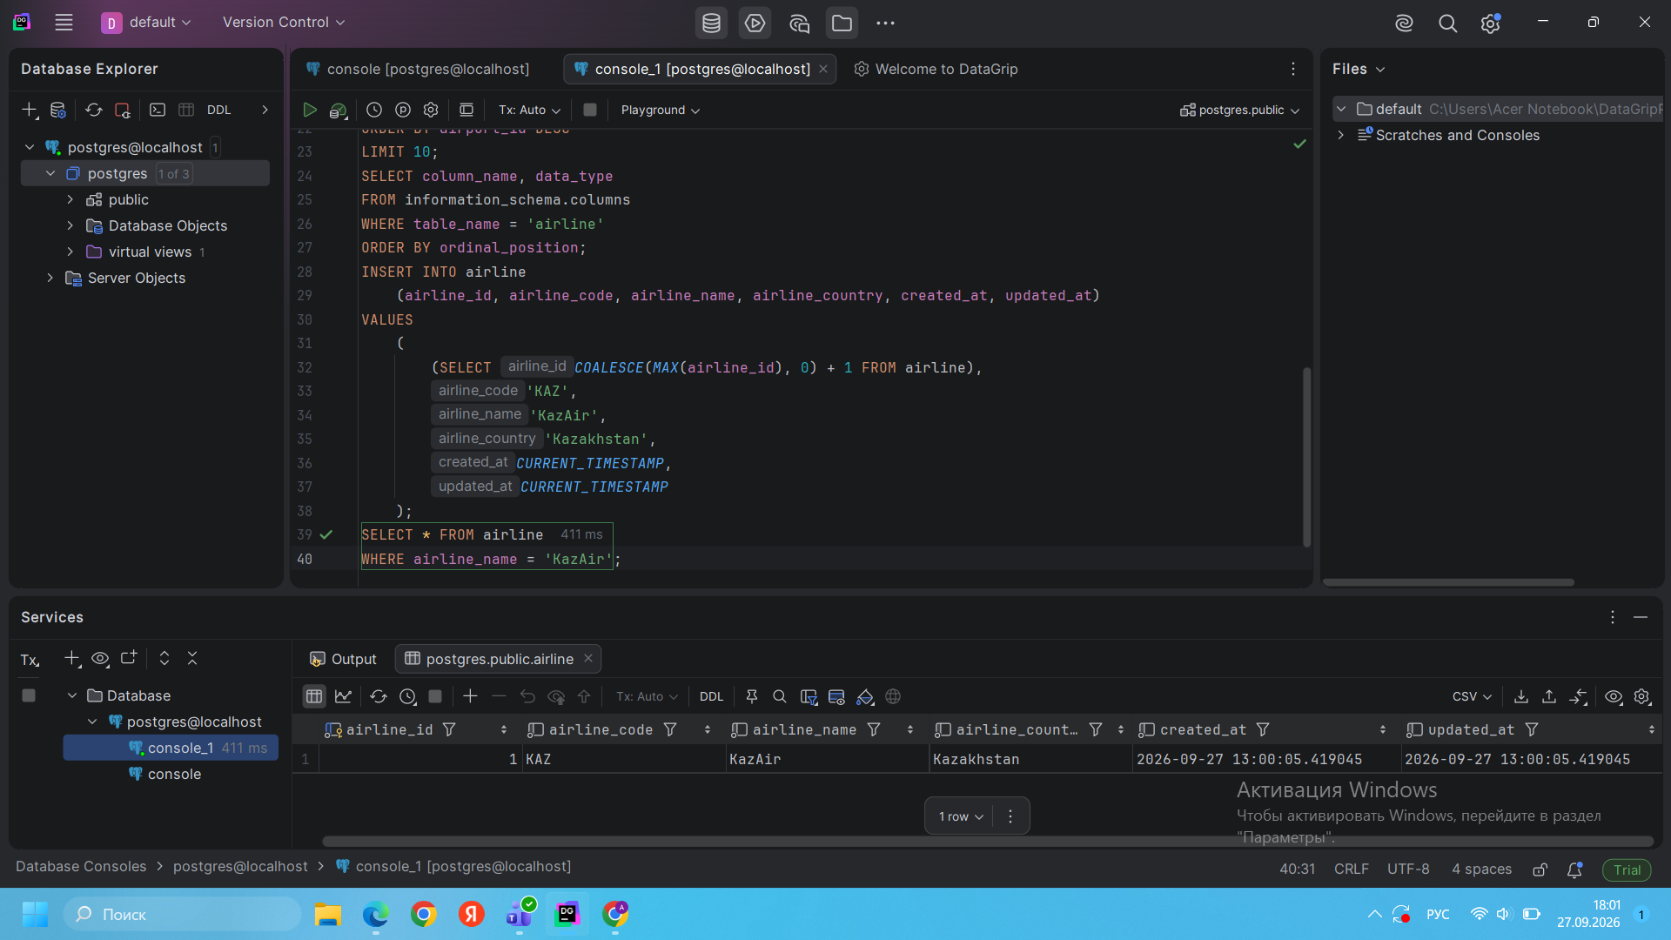
Result: The airline KazAir was successfully added to the airline table with country Kazakhstan.
Task 3. Update the country of KazAir to Turkey.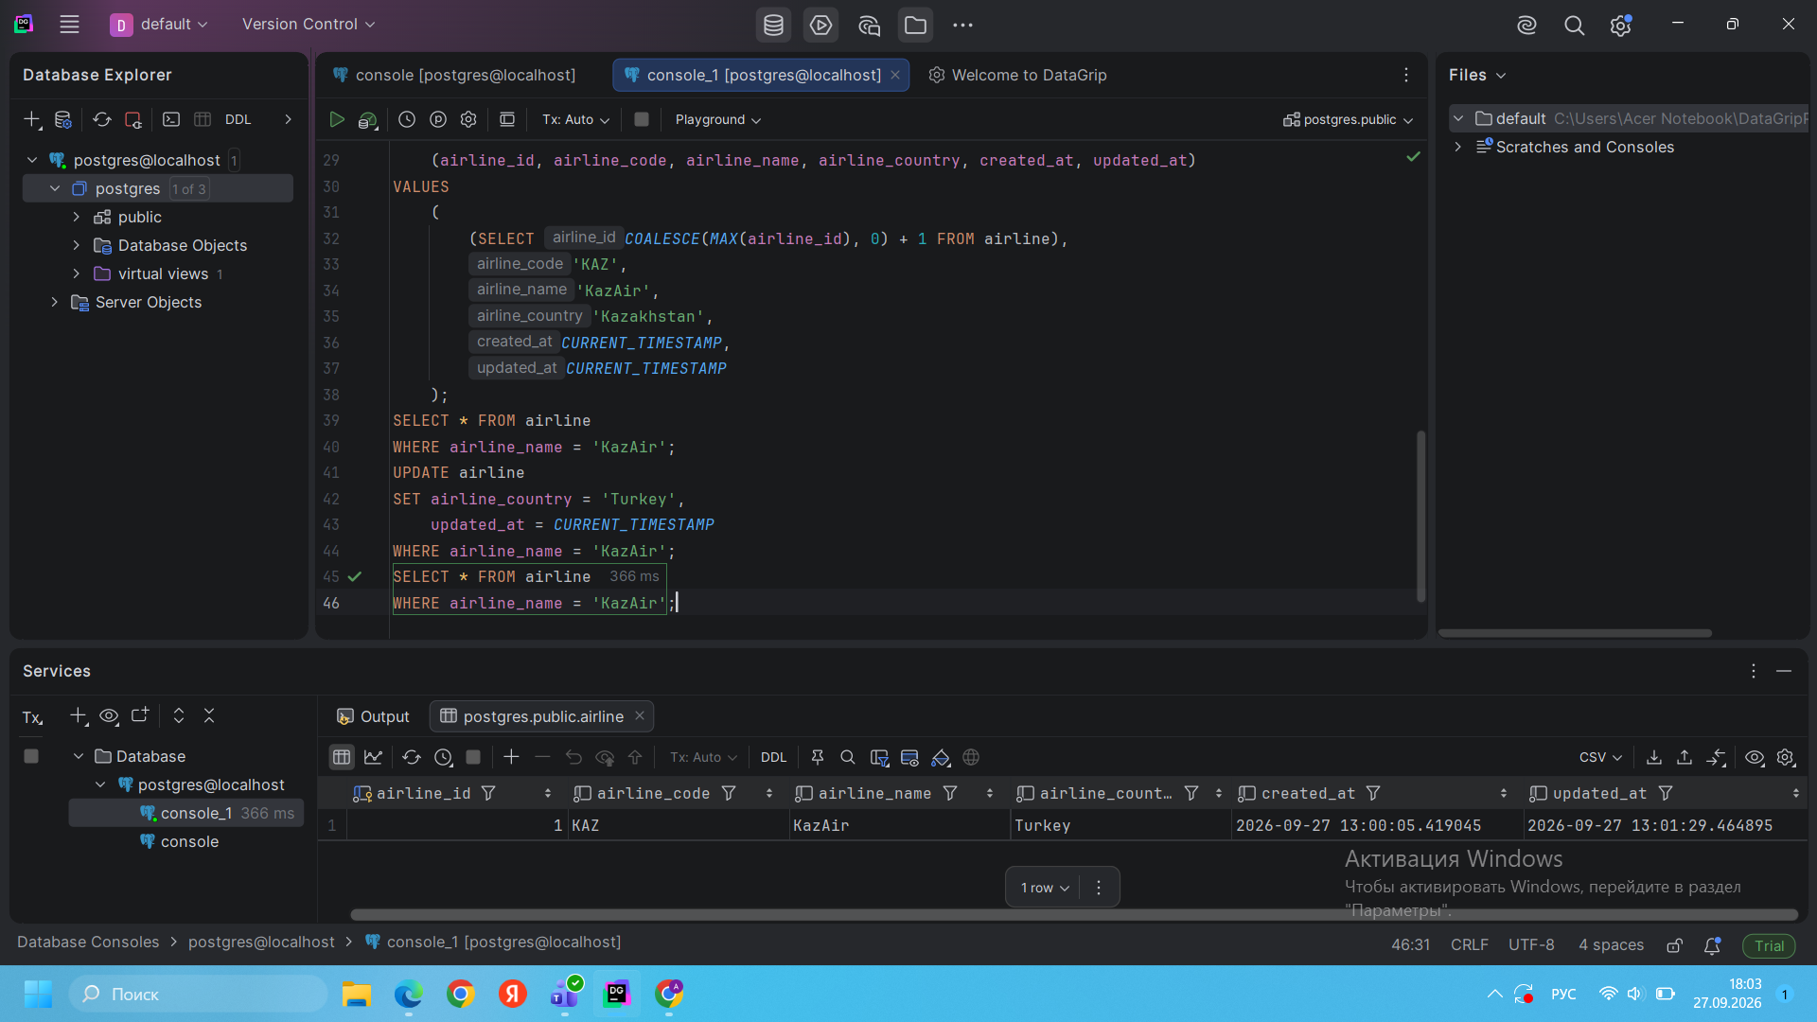
Result: The country of KazAir was successfully changed from Kazakhstan to Turkey.
Task 4. Add three airlines at once.
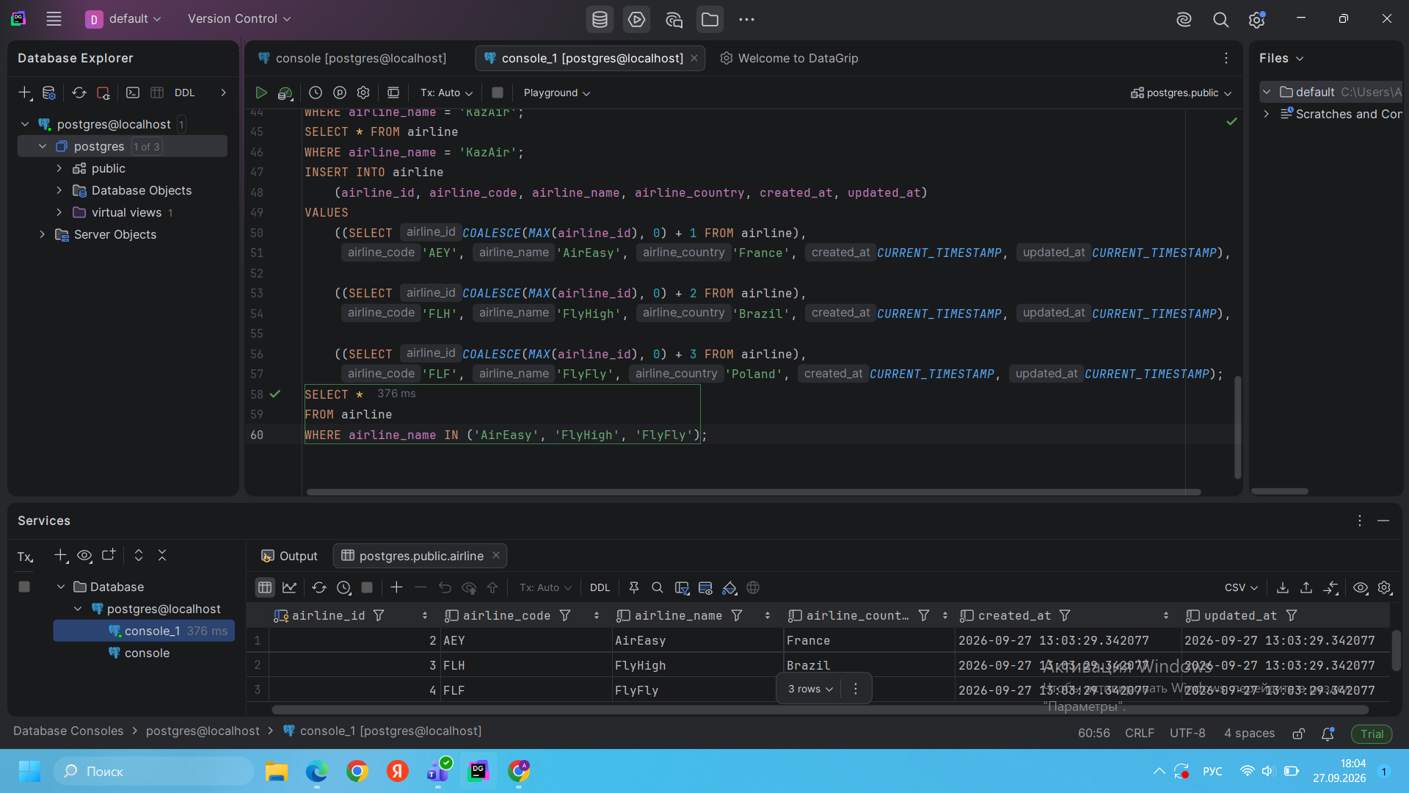
Result: AirEasy, FlyHigh, and FlyFly were successfully inserted into the airline table.
Task 5. Delete all flights whose arrival is in 2024.
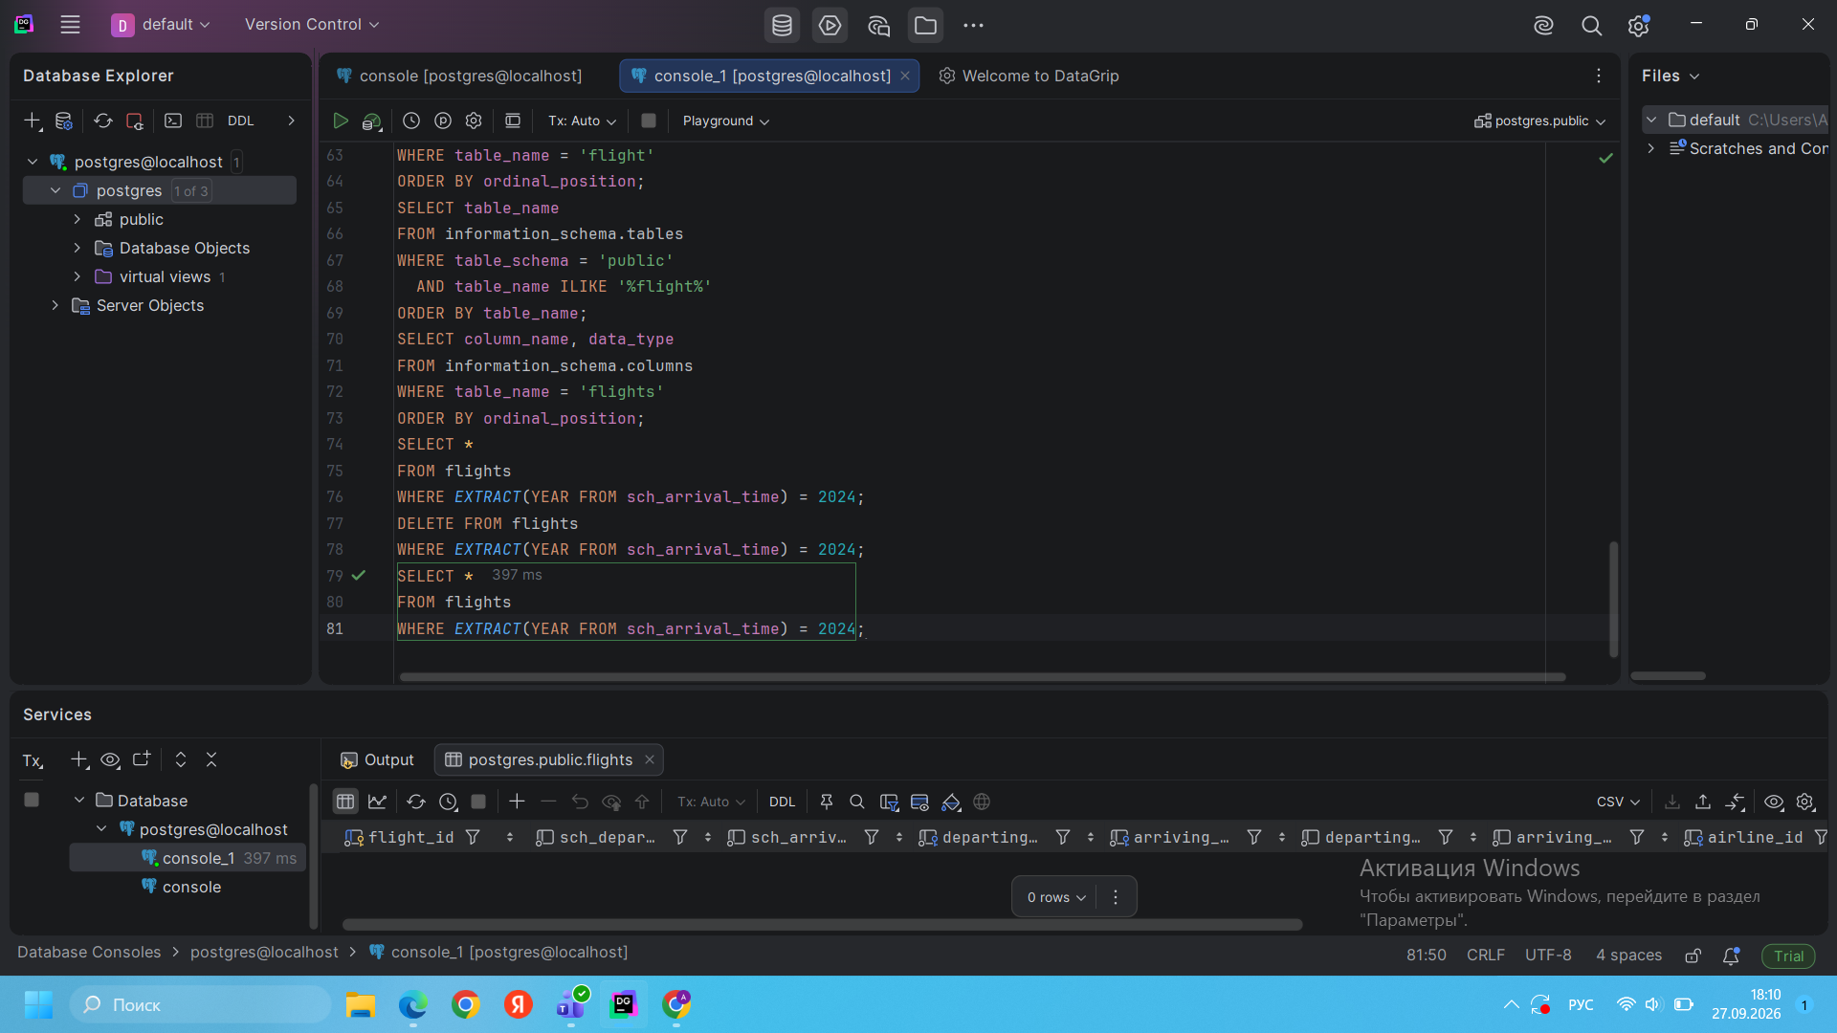
Result: All flights with arrival dates in 2024 were deleted. After verification, no matching records remained.
Task 6. Increase the price of all tickets by 15%.
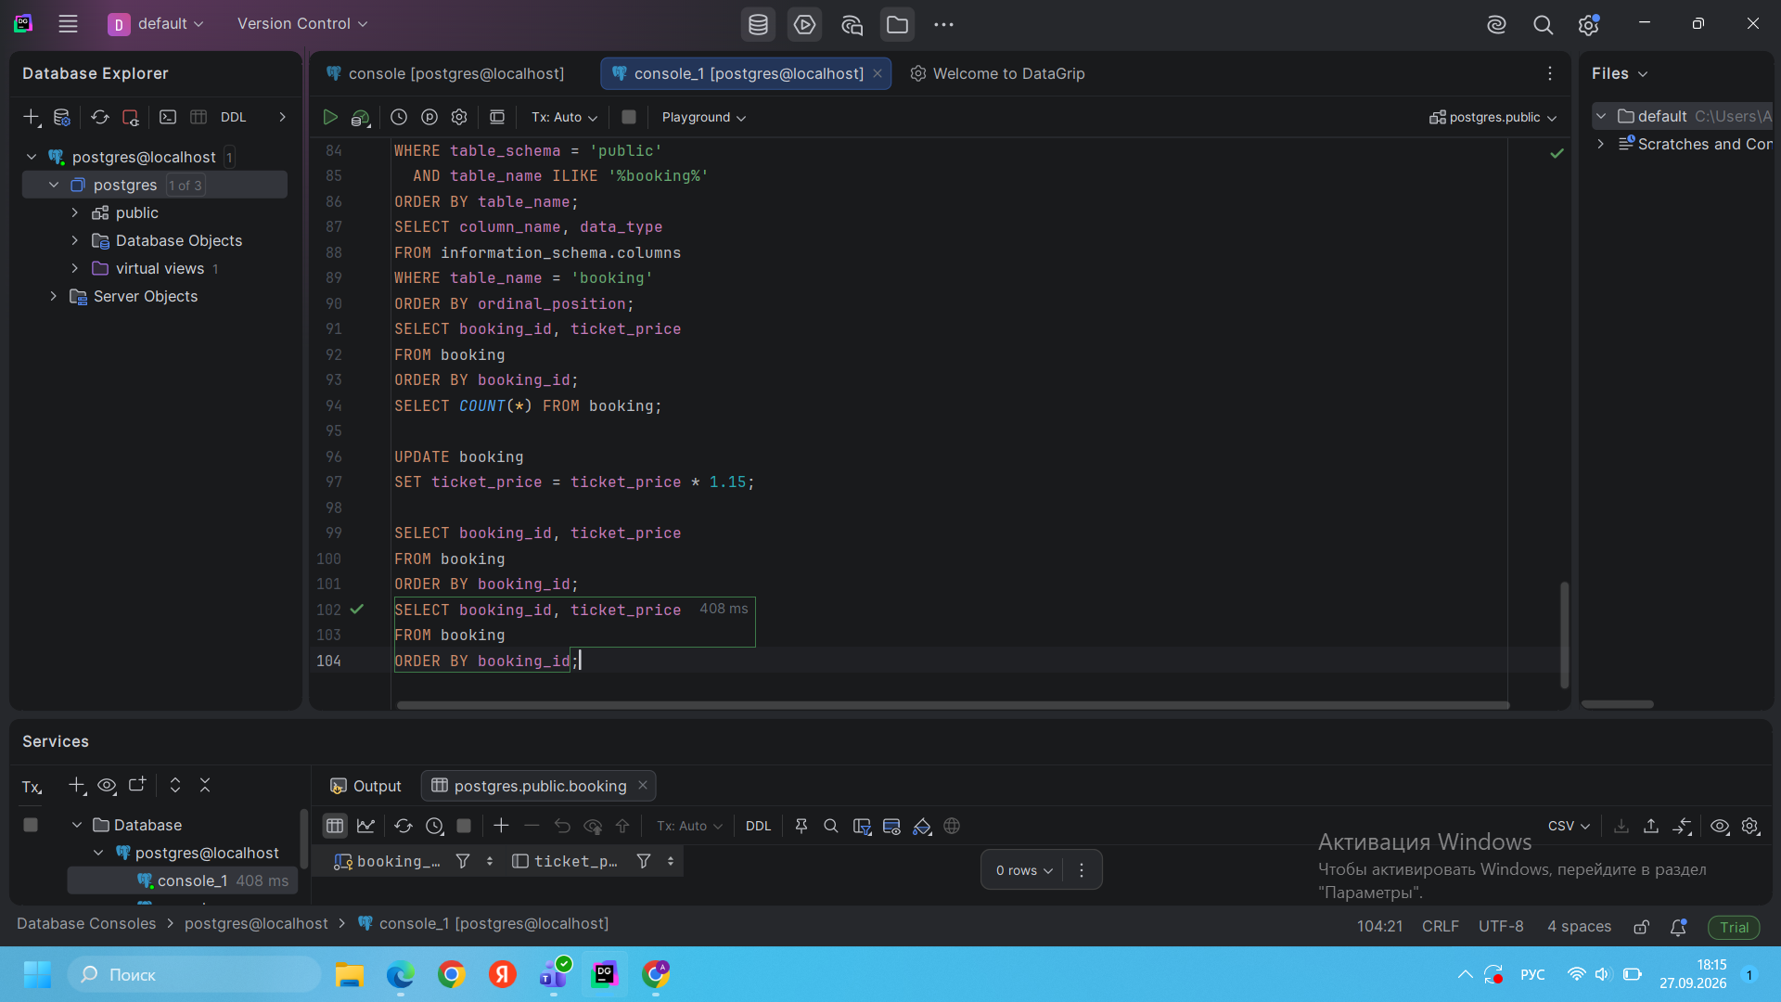
Result: The SQL update for increasing all ticket_price values by 15% was executed successfully. The booking table contained no rows at the time of execution.
Task 7. Delete all tickets where the price is less than 10000.
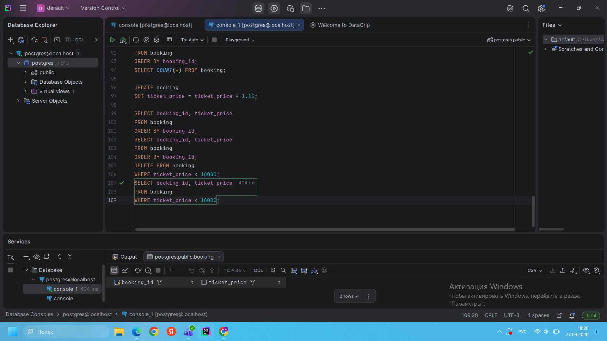
Result: All booking records with ticket_price below 10000 were removed. No matching records remained after verification.
Task 8. Set the default code ‘UNK’ where airline_code is NULL.
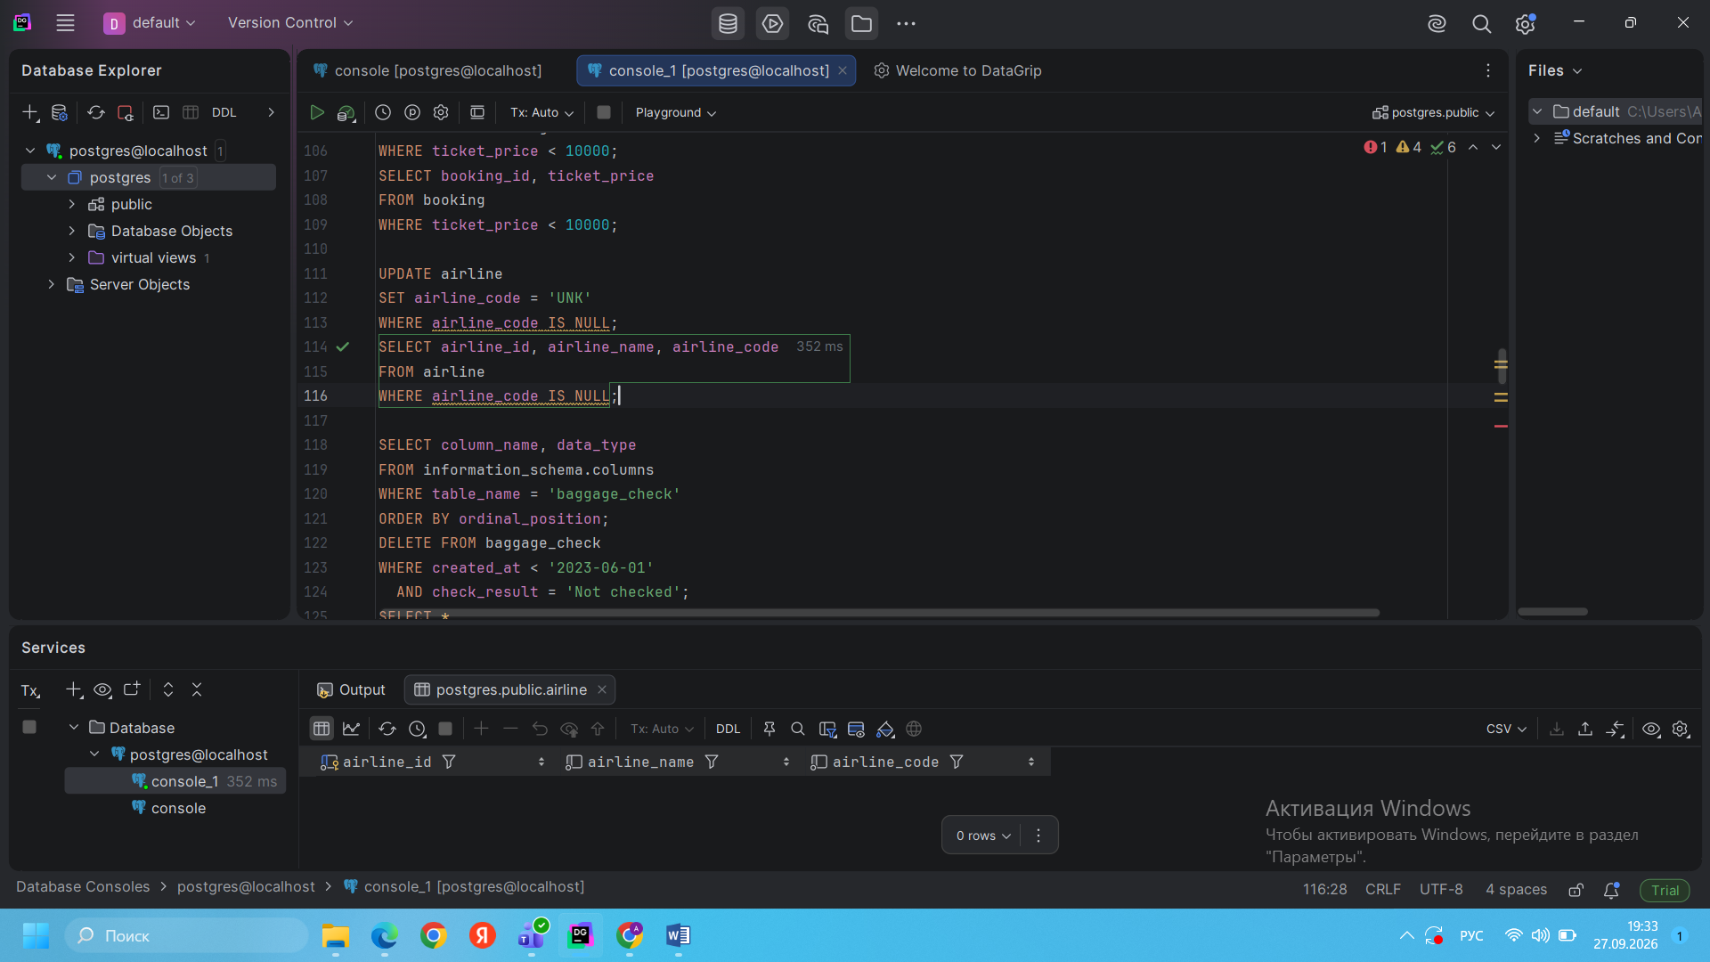
Result: All airlines with a missing airline_code were updated to UNK. After verification, no NULL airline codes remained.
Task 9. Delete old unchecked baggage check records.
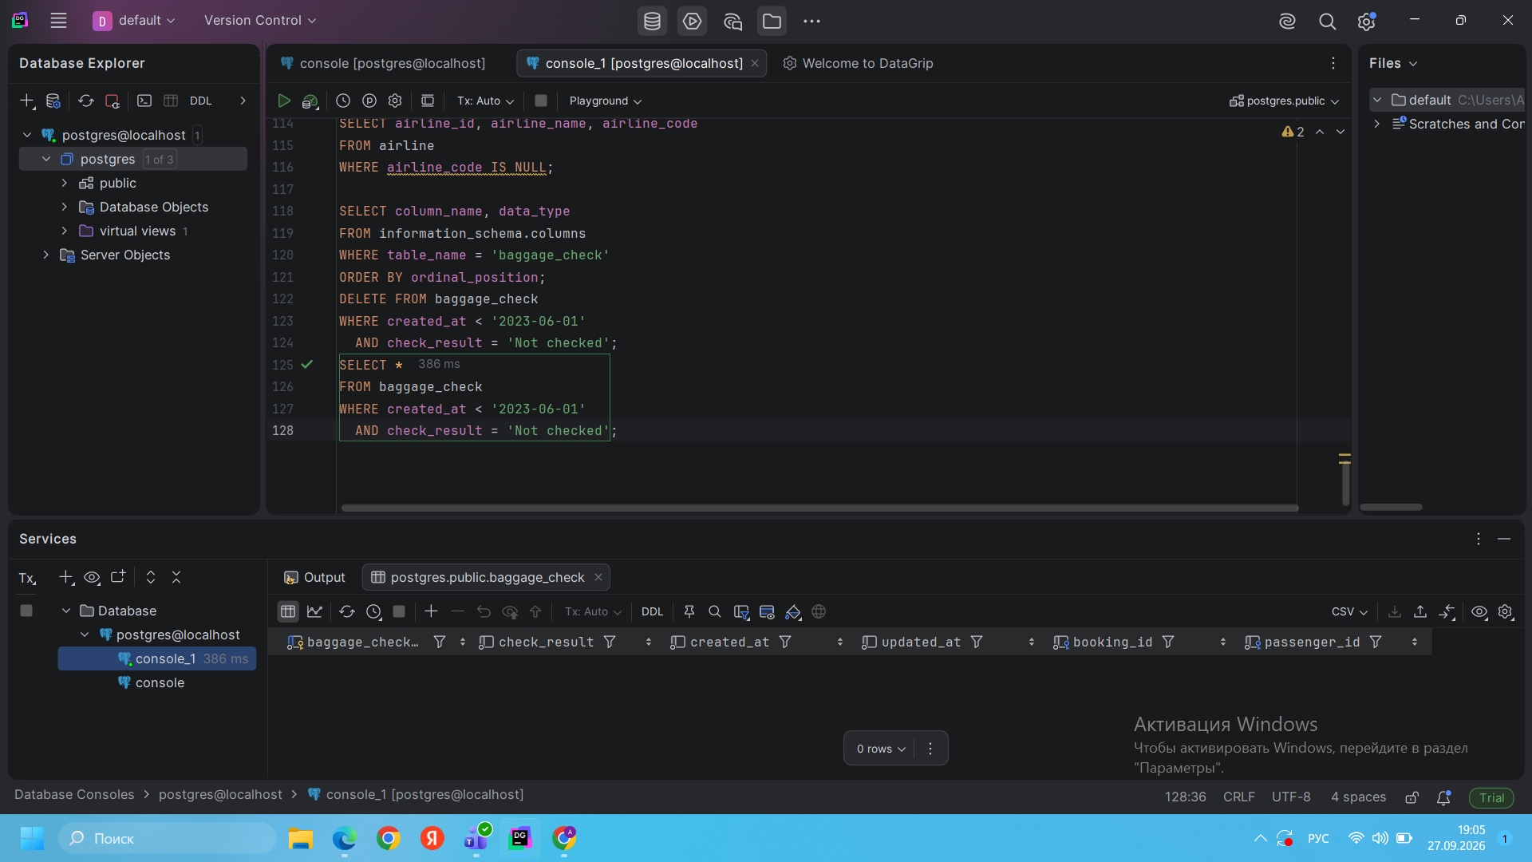
Result: Baggage check records created before June 1, 2023 with status Not checked were deleted.
Task 10. Delete airport records with missing state and specific cities.
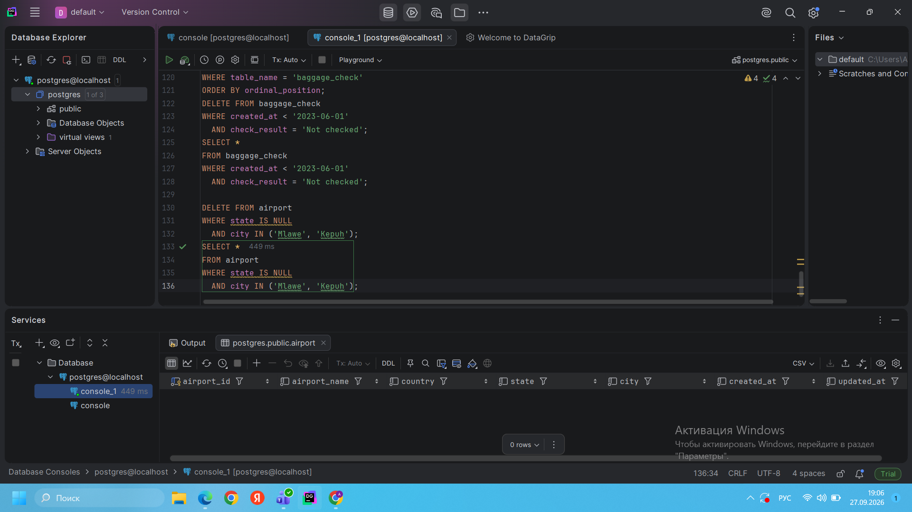
Result: Airport records where state was NULL and city was either Mlawe or Kepuh were deleted.
Task 11. Insert a new unchecked baggage inspection record and return its ID and timestamp.
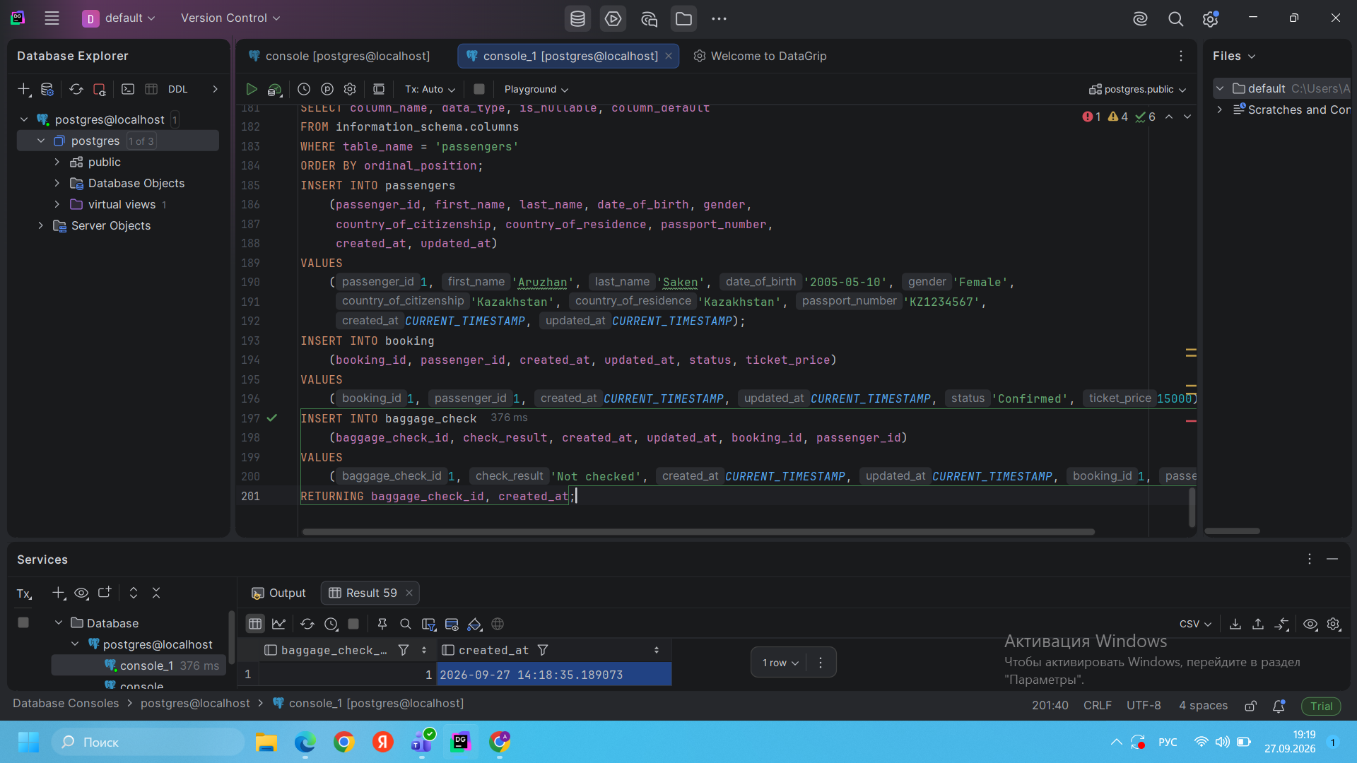
Result: A new baggage check record with status Not checked was inserted successfully. The generated baggage_check_id and created_at timestamp were returned immediately.
Task 12. Convert all airline country names to uppercase.
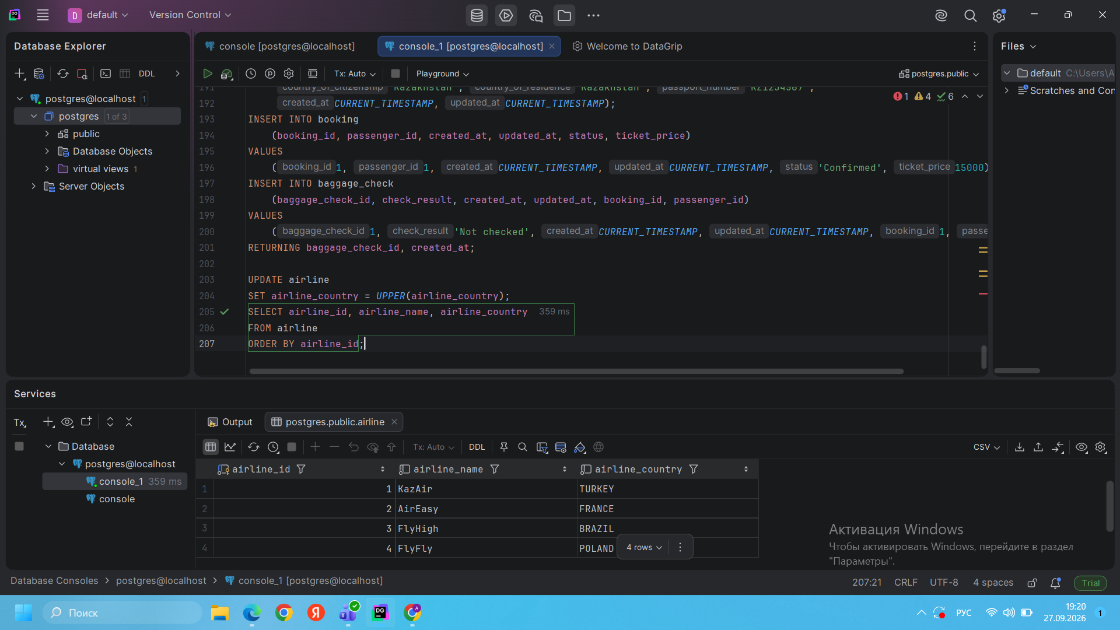
Result: All values in airline_country were successfully converted to uppercase for data consistency.
Task 13. Update the airline with airline_id = 5.
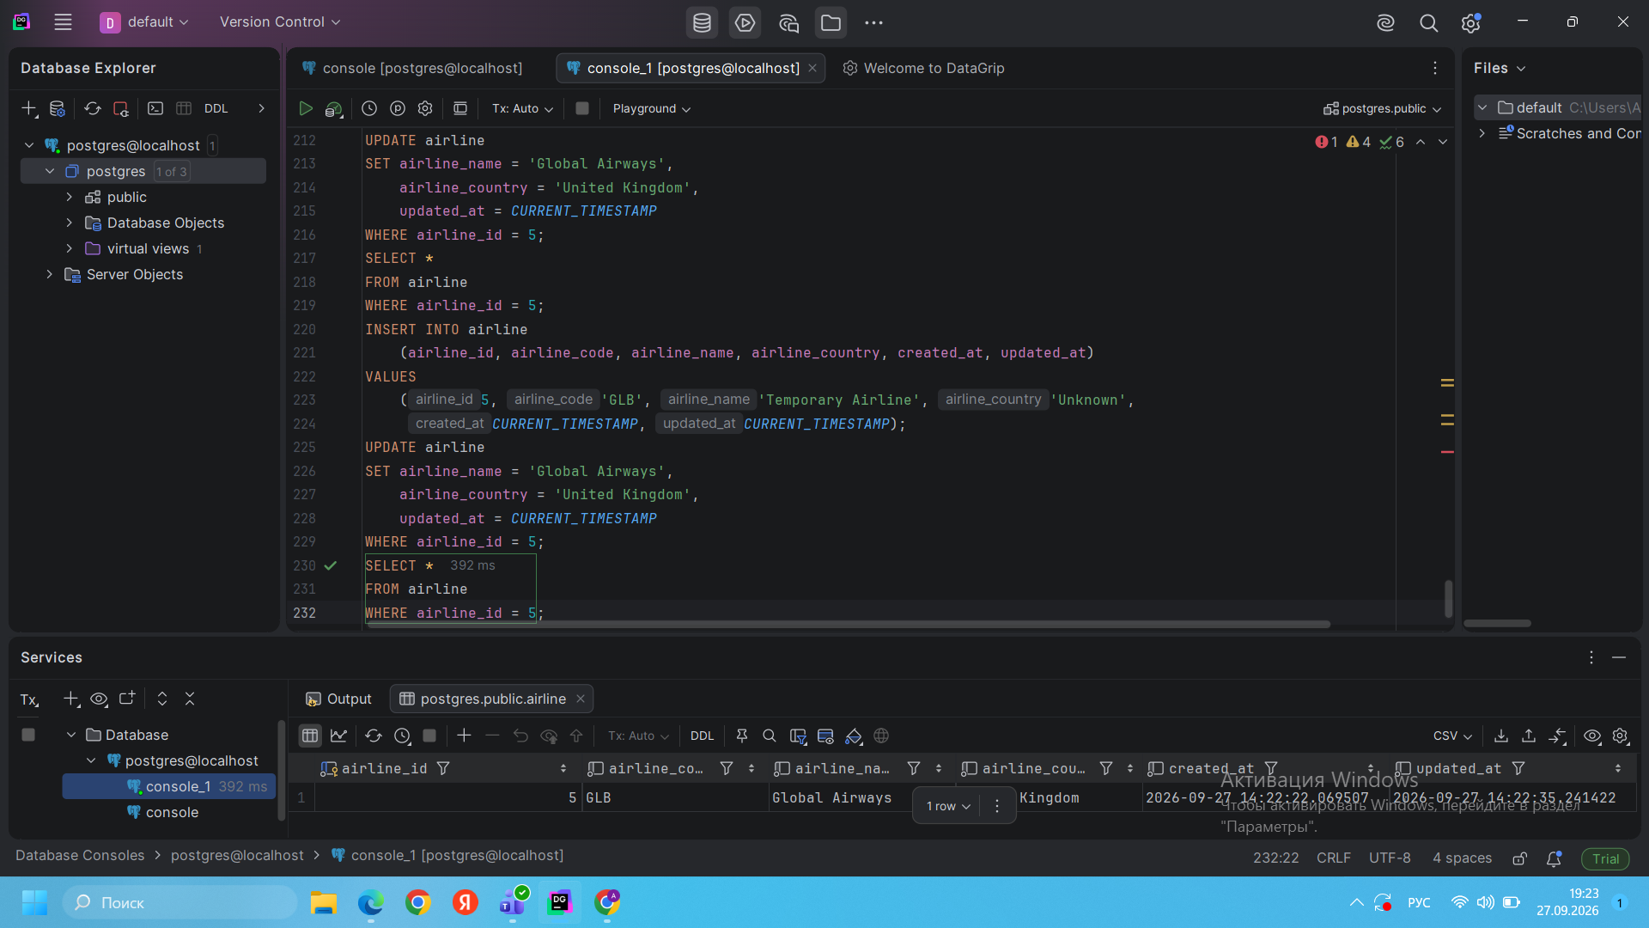
Result: The airline with airline_id = 5 was updated to Global Airways, country United Kingdom, and its updated_at value was changed to the current timestamp.
Task 14. Set state to “Capital District” for specific cities.
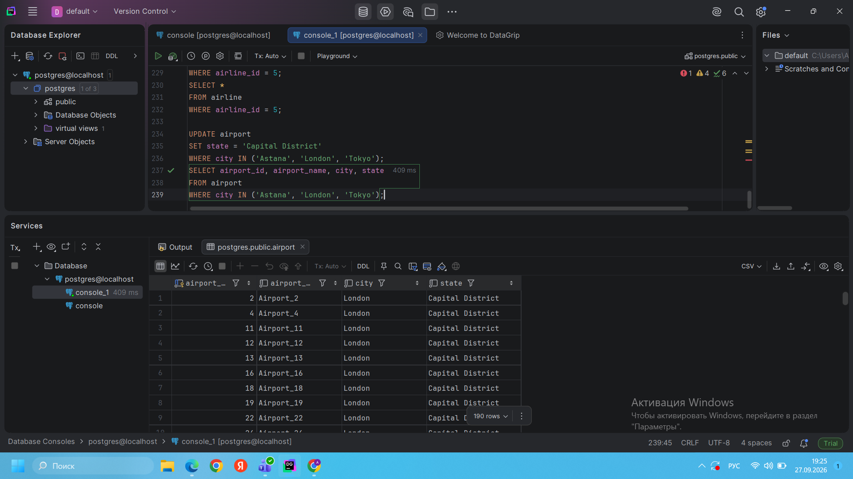
Result: Airports located in Astana, London, and Tokyo were updated so that their state value became Capital District.
Task 15. Mark March 2024 unchecked baggage checks as checked.
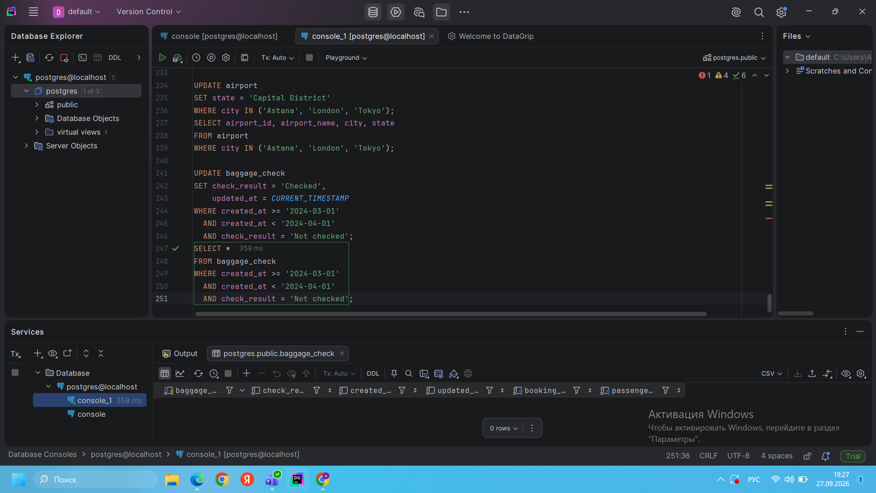
Result: All baggage check records created in March 2024 with status Not checked were updated to Checked. After verification, no matching unchecked records remained.

